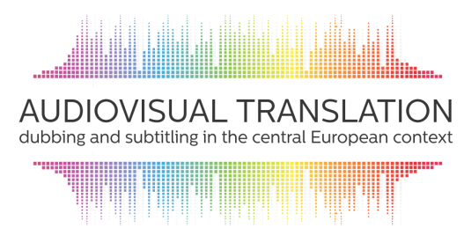
Audiovisual translation:
Dubbing and subtitling in the central European context

15 – 17 June 2016
Department of Translation Studies, CPU Nitra, Slovakia
in cooperation with European Association of Audiovisual Translators (AVTE)

Within the last couple of decades, an increased interest in audiovisual translation (AVT) within the scope of translation studies and intercultural communication in Europe can be observed. An escalating need to reflect this specific type of translation communication has emerged from various cultural, social, geopolitical and technological changes which have taken place at both a global and local level. Because of the impact of these changes, approaches and views on media and translation practice are being modified and the demands of the translation market are becoming more salient. This influences reflection upon AVT, stimulates the emergence of new interdisciplinary approaches and defines more particular requirements in translation training. Audiovisual translation has also attracted the attention of the European Union, mainly in relation to its efforts to make the individual cultures of member states available to all EU citizens. Due to economic and technological pressures the quality of AVT has become a topical issue in the last decade as well.

Aiming to map the situation in AVT practices in the central European context, the goal of the conference is to provide an opportunity for scholars and practitioners in AVT and related areas to present their approaches, research and experience. The ambition of the organisers is to initiate a discussion on the specifics of theory, criticism, translation training and AVT practice in the defined cultural and geographical area – with respect to its translation tradition, language and cultural context as well as the demands of the translation market.

The conference will provide a platform for presentations and discussion focusing mainly at the following topics:
- Audiovisual translation: theory vs practice
(history and development of AVT, theoretical approaches, translation competence and specialised training, specifics of translation practice)
- Tradition and innovation in AVT
(new approaches and technologies in AVT, quality standards, fansubbing and fan dubbing )
- Communication, translation, manipulation
(AVT modalities, ideology in translation, meaning manipulation, censorship)
- One country – two translations
(pluricentric versions in AVT, bilingual subtitling, language diversity)
- Audiovisual translation: accessibility and reception
(subtitling for the deaf and hard-of-hearing, artistic interpretation into sign language, audiodescription, target audience reception)
- Audiovisual media and translation practice in the central European context
(translation from/into languages of limited diffusion, market requirements, working conditions, legal aspects, intellectual property, translator status)

Applicants interested in participating are kindly asked to send a 250-300 word proposal for their paper together with a short bionote and name of their affiliate organisation by 15 March 2016 to: avtnitraconference@gmail.com

All information can be found at:
https://avtnitraconference.wordpress.com/

Scientific committee:  Henrik Gottlieb (University of Copenhagen)  Elena Di Giovanni (University of Macerata)  Agnieszka Szarkowska (University of Warsaw)  Frieda Steurs (KU Leuven)  Edita Gromová (Constantine the Philosopher University)  Emília Perez (Constantine the Philosopher University)  Nijole Maskaliuniene (Vilnius University)  Nike Pokorn (University of Ljubljana) | Organizing committee:  Emília Perez  Edita Gromová  Soňa Hodáková  Jozef Štefčík  Igor Tyšš  Andrej Zahorák  Oľga Desetová

