“Up to University” EU funded Project (Up2U) – “University as a Hub” sub-project (U-Hub)
Learning Path: "Education towards Critical Thinking" (ECT)
Texts choice and remixing: Giovanni Toffoli and Stefano Lariccia – Sapienza Università di Roma, DigiLab and LINK srl
Content revision and English translation: Ingrid Barth – Tel Aviv University (TAU), Division of Foreign Languages.
Most texts are inspired by: “Educazione al pensiero critico” (Editoriale Scientifica) by Francesco Piro – Università degli studi di Salerno, Dipartimento di Scienze Umane, Filosofiche e della Formazione.
Some feedback has been provided by Vindice Deplano, Pragma srl, who has taken care of the transposition of the path into interactive learning units.
Most translations between English and Italian have been drafted with GoogleTranslate and www.DeepL.com/Translator.

UNIT 4.2 – Aristotelian syllogisms

From propositional calculus to predicate calculus
We already noticed that the the propositional calculus does not consider how an elementary statement is made within it, it does not enter into the merits of what it states; nor does it take into consideration what connection exists between the elements of discourse and the objects outside the discourse to which they refer. We could also say that the propositional calculus is not interested in the meaning of statements, but only in the form of complex statements.
If we tried to express the reasoning
All men are mortal, Socrates is a man, so Socrates is mortal.
using only the connective elements of propositional logic, we should represent it as follows:
p, q ├ r
this formula is obviously not correct, because in general, from two statements, no arbitrary third can be derived; we note that this formula does not reflect the fact that the word Socrates occurs in two of the statements, as well as the word man (if we prescind from the singular-plural declension). The validity of the inference contained in the argument, however obvious, cannot be established on the basis of the relationships between the three component propositions, but only on the basis of the relationships between the terms occurring inside them [2].

Categorical logic
The limit of propositional calculus is overcome by the predicate calculus. Historically, the first step was represented by modeling each statement as a pair of subject and predicate, united by the copula "is" or "are", in which the subject S can stand for an individual or for a set of individuals and the predicate P affirms some property of the subject. The general scheme is
S is P
The statements of this type are called categorical and their study is also called categorical logic; in Aristotle the categories identify their members in intentional terms: they act as definitions by collecting all the properties that can be preached about their members.

Particular and general statements, affirmative and negative statements
The statement scheme S is P can be differentiated into four types
A - universal affirmative: every S is P (es: every man is generous)
I - particular affirmative: some S is P (es: some man is generous)
E - universal negative: no S is P (es: no man is generous)
O - particular negative: some S is not P (es: some man is not generous)
where capital vowels were chosen by medieval Aristotelian logicians to designate the four types of statements, extracting them from the Latin words AdfIrmo and nEgO.
As you would probably expect
- in general or universal statements, words like every, all, none typically occur,
- in particular statements typically occur words like some or names denoting specific individuals.
The same logicians have also invented an ingenious way of arranging the four types of categorical statements at the vertices of a square of opposition
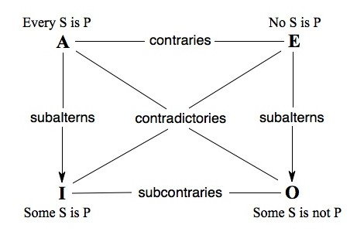
where sides and diagonals are labelled as follows:
A-E “contraries”: the statements cannot both be true
I-O “subcontraries”: the statements cannot both be false
A-I e E-O “subalterns”: the particular statement of each pair can be inferred from the general one
A-O e E-I “contradictories”: the elements of each pair have opposite truth values
We can consider the above constraints, between statements having the same subject and the same predicate, but different scope (universal or particular) and different sign (presence or absence of negation), as criteria for deciding on the validity or otherwise of the many types of syllogism that are obtained by combining in all possible ways categorical statements: universal and particular statements, affirmative and negative.

Syllogism and syllogisms
The reasoning on Socrates which, as a man, is mortal, constitutes an example of syllogism. There is a whole family of forms of demonstrative reasoning, initially studied by Aristotle and called categorical syllogisms, which have in common the following general characteristics:
- they concatenate three categorical statements, which must include a premise of universal scope (major premise), a second premise (minor premise) and a conclusion
- at least one of the premises is affirmative, i.e. the premises cannot both be negative
- each of the terms that occur in the conclusion must also occur in one of the premises
- a middle term is needed occurring in in both premises
- if one of the premises is negative, the conclusion will also be negative
- the conclusion has the same "strength" as the "weaker" premise: it is sufficient that a premise is particular for the conclusion to be particular; but if both premises are universal, the conclusion must also be universal.
Try to re-read the syllogism on Socrates to realize that it respects these characteristics.
The main forms of Aristotelian syllogism, also known as figures, are distinguished by the position of the middle term within the premises. We briefly illustrate three of them; of the fourth we provide only the characteristic scheme.

The interpretation of syllogisms in extensional terms
The rules of syllogisms can be made intuitive by giving an extensional interpretation in terms of sets and a set representation with the Venn diagrams. If we label A the set of the subjects of category S and label B the set of subjects of category P, the following figures provide representations with Venn diagrams of the four syllogism types at the vertices of the square of opposition.

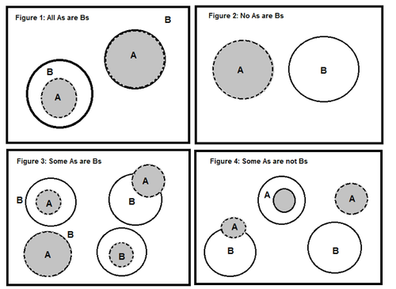
Venn diagrams for the syllogism types in the square of opposition – from [5]
Here is the mapping to the formulation in terms of sets from that in terms of categories (in parentheses):
- Figure 1: every element of A is an element of B (all S are P)
- Figure 2: no element of A is an element of B (no S is P)
- Figure 3: some elements of A are also elements of B (some S are P)
- Figure 4: some elements of A are not elements of B (some S are not P)
A few additional remarks:
- Figure 1 doesn’t exclude that also all Bs are As (in that case sets A and B coincide); Figures 3 and 4 show several subcases
- Figures 1 and 3 illustrate subalternity for affirmative syllogisms by making evident that some As are Bs is a particular case of all As are Bs
- Figures 2 and 4 illustrate subalternity for negative syllogisms by making evident that some As are not Bs is a particular case of no As are Bs.

The "figures" of the syllogism

The first figure of syllogism
The example given above, which we report here for convenience
All men are mortal, Socrates is a man, so Socrates is mortal
constitutes, more specifically, an example of the syllogism of the first figure, in which the middle term - underlined - occurs as the subject of the major premise and as the predicate of the minor premise (the less universal one):
- man / men is the middle term, which appears in both premises
- the major premise, All men are mortal, in this case it is affirmative
- the minor premise, Socrates is a man, in this case also affirmative.
If we schematize each statement with a pair of letters of the type S/P, where S stands for subject and P for predicate (subject/predicate), and then we replace S or P with M in the position of the middle term, the three statements of the first figure can be schematized in the order as M/P, S/M, S/P.

Valid modes for the syllogisms of the first figure
It can be shown that, among all the combinations compatible with the syllogism scheme of the first figure (M/P, S/M, S/P), the subtypes - or modes - below are valid:
All children are intelligent, All brats are children, so All brats are intelligent.
No fish has lungs, All carp are fish, so No carp has lungs.
All professors are clowns, Some wise men are professors, so Some wise men are clowns.
No mammal is a fish, Some aquatic animals are mammals, so Some aquatic animals are not fish.
In fact, we see that they all meet the 6 general characteristics of categorical syllogisms and the scheme of the first figure. In the examples the middle term has always been underlined.

The other figures of the syllogism

The second figure of the syllogism
We have the second figure when the middle term occurs as a predicate in both premises; it can be schematized as S/M, S/M, S/P. The modes of this figure give rise only to negative conclusions.
Let's give only one example:
No honest person is a liar, Some politicians are liars, so Some politicians are not honest.

The third figure of the syllogism
We have the third figure when the middle term occurs as the subject in both premises; it can be schematized as M/P, M/P, S/P. The modes of this figure give rise only to particular conclusions.
Let's give only one example:
All Canadians are North Americans, Some Canadians are tall, so Some North Americans are tall.

The fourth figure of syllogism
The characteristic scheme of this figure is P/M, M/S, S/P.

BIBLIOGRAPHY AND WEBOGRAPHY
[1] Francesco Piro, Manuale di educazione al pensiero critico. Comprendere e argomentare, prefazione di Tullio De Mauro, Editoriale Scientifica, Napoli, 2015, pp.280
[2] CIDI - Centro di iniziativa democratica degli insegnanti (a cura di), Introduzione alla logica, Editori Riuniti, 1976
[3] Matematica online – YouMath, Implicazione (2018)
https://www.youmath.it/domande-a-risposte/view/6992-implicazione-matematica.html
[4] Stanford Encyclopedia of Philosophy, The Traditional Square of Opposition.
https://plato.stanford.edu/entries/square/
[5] Face Prep site, Various methods to solve syllogism questions
https://www.faceprep.in/aptipedia/knowledgebase/various-methods-to-solve-syllogism-questions/

